Title: Bats adjust flight speed to create personal listening channels

**Abstract:** Acoustic signaling in animals is susceptible to interference from conspecifics and other sources. This problem has received considerable attention in echolocating bats and sparked a hot debate over reports of putative sonar jamming avoidance responses in animals flying in close proximity. In this debate, a key behavioral variable has been neglected, namely bat flight speed. Here, we report novel findings that feature the bat’s active control over flight speed to modulate echo Doppler shifts, and thereby serve to open listening channels of individual great Himalayan leaf-nosed bats (*Hipposideros armiger*), a species that produces sonar calls with constant frequency (CF) and frequency modulated (FM) components. We employed high-density microphone arrays and advanced signal processing algorithms to assign echolocation calls to individual bats flying in groups of varying size in a laboratory flight room. Bats increased the duration, bandwidth, and source pressure level of their echolocation calls as the number of bats increased. They also adjusted the CF component of their sonar calls to amplify spectral differences between their echoes and those from neighboring bats. Notably, we made the surprising discovery that bats adjusted their flight speed to further boost spectral differences between echoes from their calls and acoustic signals produced by conspecifics. These findings demonstrate, for the first time, a coordinated strategy of flight speed control and vocal adjustments to carve out personal listening channels by echolocating bats flying in groups.

**Main Text:**

While active sensing enables echolocating bats to navigate and forage in darkness, it also leaves them susceptible to signal interference from nearby conspecifics (*1*). The acoustic signals of bats flying in groups create a sound cacophony that challenges each animal’s ability to process echoes from its own calls to localize and track moving prey in the environment. While many reports assert that bats alter acoustic signal parameters to minimize interference in the presence of conspecifics (*2*-*8*), others have challenged the utility or operation of jamming avoidance response (JAR) in bats (*9*-*14*). Given the debate surrounding bat JAR, many questions remain unresolved, and importantly, a key behavioral adaptation to mitigate signal interference has not been previously considered. This behavioral adaptation, flight speed adjustment, affects the sound frequency of echoes returning to the bat’s ears. Doppler shift compensation is well documented in bat species that use constant frequency (CF) echolocation signals, whereby flying animals lower call emission frequency to offset echo frequency shifts proportional to their velocity (*15*, *16*). Here, we report, for the first time, that bats flying in large groups actively adjust flight speed to exploit the Doppler effect to create private echo listening channels.

We investigated the adaptive adjustment of echolocation call parameters and flight speed of the great Himalayan leaf-nosed bat (*Hipposideros armiger*), which broadcasts a sound with a long constant frequency (CF) component followed by a downward frequency-modulated (FM) sweep. Bats flew in groups ranging in size from two to 10 individuals in a large laboratory flight room (Fig. 1A). We employed advanced signal processing algorithms to accurately assign each echolocation signal to the individual calling bat, allowing for analysis of signal parameters and flight speed of every bat. Conspecific interference encountered by bats includes both the direct calls of other bats and echoes of these calls from targets and obstacles, such as neighboring bats (Fig. 1B). Past research reports that bats adjust call parameters of their signals to reduce acoustic interference in complex environments (*2*-*13*, *17*-*22*). In addition, bat flight velocity affects echo frequency (*14*). Thus, we hypothesized that bats, in addition to adjusting their echolocation call parameters when flying in groups, actively control flight speed, exploiting the Doppler effect, to create private echo listening channels.

Two fixed arrays, each with 64 distributed microphones, were used to record echolocation calls from bats flying individually and in groups (Fig. 1A). We successfully recorded the echolocation calls of individual bats in every flight and employed signal processing algorithms to assign each sonar signal to the calling individual. Specifically, for each array, the Multiple Signal Classification algorithm was used to estimate the azimuth and elevation angles of bats, then the Linearly Constrained Minimum Variance algorithm was applied to separate signals from different individuals and to assign calls to specific individuals (Fig. 1C). Subsequently, the Wigner-Ville Distribution was employed to measure signal parameters. The three-dimensional positional coordinates of bats as they emitted each echolocation call were calculated based on a hybrid of the Time Difference of Arrival and Angle of Arrival from the two arrays (Fig. 1D). Finally, flight speed was determined using the coordinates and time differences at two adjacent recorded signals (details are provided in the supplementary materials).

Acoustically, the parameters of bat echolocation calls varied with changes in group size (Kruskal-Wallis H test, *P* < 0.05; Fig. 2, A to E). In all measured call recordings with high signal-to-noise ratio, post hoc independent contrasts indicated that the CF duration gradually increased from 5.02 ± 0.79 ms (mean ± SD) in individual flights to 5.88 ± 1.44 ms in groups of six and stabilized in larger groups of bats (Fig. 2A and Table S1). Similarly, FM bandwidth gradually expanded from 7.83 ± 0.97 kHz in individual flights to 9.76 ± 1.37 kHz with groups of seven and stabilized in larger groups of bats (Fig. 2B and Table S2). The FM duration, however, exhibited a more intricate pattern, gradually rising from 1.24 ± 0.26 ms in individual flights to 2.4 ± 0.7 ms with groups of four, slightly decreasing to 2.15 ± 0.76 ms with groups of five, then unexpectedly increasing again to 2.96 ± 0.78 ms with groups of six and stabilized in larger groups of bats (Fig. 2C and Table S3). The emission rate did not show a significant difference between single flights (25.57 ± 3.4) and paired flights (24.5 ± 2.8). A significant decrease in emission rates was observed in groups of three or more compared to single or paired flights; however, no significant differences were found among groups ranging from three to 10 individuals (Fig. 2D and Table S4). Additionally, the call source pressure level (SPL) increased from 84.08 ± 3.18 dB in single flights to 93.66 ± 5.67 dB with groups of six, and then remained stable (Fig. 2E and Table S5). The mean FM bandwidth was linearly correlated with the mean FM duration under each flight condition (Linear regression analysis, *R* = 0.98, *R*² = 0.964, *P* < 0.001; Fig. 2F).

To investigate bat responses to echoes from the calls of conspecifics, we analyzed CF frequency differences between the echoes returning to a bat from its own calls and sonar signals from nearby bats by constructing a range of CF frequency difference intervals, which were determined by the theoretical resolution of signal processing and measurement errors (details of the calculation methods are provided in the supplementary materials). For specific calls, when the CF frequency difference was within a range of >2000 Hz (actual data: 2354 ± 293 Hz), there was a significant decrease to 2073 ± 500 Hz in subsequent calls. For differences within the range of 0-90 Hz (actual data: 42 ± 24 Hz) and 90-270 Hz (actual data: 187 ± 52 Hz), there was a significant increase to 272 ± 231 Hz and 423 ± 342 Hz in subsequent calls, respectively (Wilcoxon Signed-Rank test, *P* < 0.001; Fig. 3A). In contrast, for CF frequency differences in other ranges, bats did not show significant adjustments in sonar emission frequencies (Wilcoxon Signed-Rank test, *P* > 0.05; Fig. 3A). Moreover, the distribution of frequency differences among bats shows that the peak of the distribution is 14.52% at 500±100Hz (Fig. 3B) and as the number of bats increases, the frequency range occupied by the CF frequencies expands (Linear regression analysis, R = 0.89, R² = 0.8, P < 0.005; Fig. 3C). Figure 3D shows the representative changes in CF frequency of returning echoes to a target bat during a group flight of three bats and the CF frequencies of the echoes from the other two bats. These data show that when the CF frequency difference was less than 270 Hz (actual data: 19 Hz), there was an increase in the CF frequency difference in subsequent calls (actual data: 234 Hz).

We calculated the changes in CF frequency of emission calls and flight speed between each call and the subsequent call. In instances where the CF frequency difference was less than 270 Hz and bats increased the frequency difference between its calls and conspecific signals, significant coordination between emission frequency and flight speed adjustments was observed. When the CF frequency of the emission calls increased, 78.6% of the adjustments were accompanied by an increase in flight speed. Conversely, when the emission CF frequency decreased, 88.5% of the adjustments were accompanied by a reduction in flight speed. In other scenarios, adjustments in sonar call emission frequency and flight speed exhibited a symmetrical pattern: an increase in CF emission frequency tended to accompany a decrease in flight speed 80.0% of the time, and a decrease in emission frequency tended to accompany an increase in flight speed 72.7% of the time (Fig. 3E).

We observed that as the number of bats in the flight room increased, the FM bandwidth of sonar calls widened, thereby enhancing localization accuracy (*23*), and the duration increased, which enhances object detection (*24*). These results are consistent with findings for *Pipistrellus kuhlii* and *Rhinolophus capensis* (*12*, *19*). In our experiments, adjustments stabilized when the number of bats exceeded six, suggesting a limit to changes in acoustic parameters within a particular environment. Previous studies on CF-FM Japanese horseshoe bats (*Rhinolophus ferrumequinum nippon*), flying in groups did not report the JAR (*14*, *25*). However, our results showed that bats could actively avoid acoustic interference by increasing the separation between their own echoes and interfering signals when the frequency difference was less than 270Hz, suggesting that JAR may have been missed in past measurements. The critical value was close to the signal processing’s frequency resolution determined by 1/T (170 ± 15 Hz), where T is the CF duration of the signal, implying a potential intrinsic relationship between the two.

Decades of research have focused on how bats respond to the presence of calls and echoes of nearby conspecifics, whereas key questions remain. First, past investigations have typically considered adaptive echolocation behavior among a small number of individual bats in group flight, which may have not adequately captured the acoustic complexity and dynamics of echolocating bats operating in larger numbers in the natural world. Second, current research methodologies may fall short in accurately assigning each sonar signal to the individual calling bat flying in large groups. Finally, previous studies have not considered the complex echoes received by individual bats from nearby conspecifics, which can also produce echo interference. Importantly, past work did not consider Doppler shifts in echo frequency, which can be amplified by adjustments in animal flight velocity.

Here, we discovered coordinated control of sonar call emission frequency and flight speed in bats, whereby these joint motor adjustments served to create personal listening spaces for individual echolocating animals. Specifically, when the received CF echo frequency difference between two bats was initially small, bats actively adjusted flight speed, along with call frequency, to increase the separation of sonar signals. When both the emission CF frequency and flight speed increased or decreased simultaneously, their effects on echo frequencies were cumulative. This means that if call frequency and flight speed both change in the same direction (increase or decrease), the echo frequency differences were amplified. Through this mechanism, bats enhance the spectral separation between echoes arriving at their ears and sonar signals produced by nearby conspecifics, thereby creating their own personal listening channels.

In conclusion, we showed that bats adaptively adjust the acoustic parameters of their echolocation calls and their flight speed based on echo feedback during group flight, a strategy that enhances spectral separation and improves sonar localization accuracy (*23*). The bat’s coordinated adjustments in call frequency and flight speed mitigates acoustic interference from vocalizing conspecifics by creating personal listening spaces in complex acoustic environments. Additionally, we provided the first evidence that bats can increase echo frequency differences to avoid acoustic interference during group flight when the differences were only 0.39% of the resting frequency. These observations not only shed new light on the richness of bat adaptive behaviors but also inspire novel biomimetic applications in robotics and autonomous swarm navigation (*26-28*).

References and Notes

1. M. E. Nelson, M. A. MacIver, Sensory acquisition in active sensing systems. *Journal of Comparative Physiology A* **192**, 573-586 (2006).
2. J. C. Aaron, E. C. William, Bats jamming bats: Food competition through sonar interference. *Science* **346**, 745-747 (2014).
3. N. Ulanovsky, M. B. Fenton, A. Tsoar, C. Korine, Dynamics of jamming avoidance in echolocating bats. *Proceedings of the Royal Society of London. Series B: Biological Sciences* **271**, 1467-1475 (2004).
4. C. Chiu, W. Xian, C. F. Moss, Adaptive echolocation behavior in bats for the analysis of auditory scenes. *Journal of Experimental Biology* **212**, 1392-1404 (2009).
5. M. E. Bates, S. A. Stamper, J. A. Simmons, Jamming avoidance response of big brown bats in target detection. *Journal of Experimental Biology* **211**, 106-113 (2008).
6. J. M. Ratcliffe, H. M. T. Hofstede, R. Avila-Flores, M. B. Fenton, G. F. McCracken, S. Biscardi, G. Spanjer, Conspecifics influence call design in the Brazilian free-tailed bat, *Tadarida brasiliensis*. *Canadian Journal of Zoology* **82**, 966-971 (2004).
7. A. M. Adams, K. Davis, M. Smotherman, Suppression of emission rates improves sonar performance by flying bats. *Scientific reports* **7**, 41641 (2017).
8. C. Chiu, W. Xian, C. F. Moss, Flying in silence: echolocating bats cease vocalizing to avoid sonar jamming. *Proceedings of the National Academy of Sciences* **105**, 13116-13121 (2008).
9. N. Cvikel, E. Levin, E. Hurme, I. Borissov, A. Boonman, E. Amichai, Y. Yovel, On-board recordings reveal no jamming avoidance in wild bats. *Proceedings of the Royal Society B: Biological Sciences* **282**, 20142274 (2015).
10. S. Götze, J. C. Koblitz, A. Denzinger, H. U. Schnitzler, No evidence for spectral jamming avoidance in echolocation behavior of foraging pipistrelle bats. *Scientific reports* **6**, 30978 (2016).
11. Y. Lin, N. Abaid, R. Müller, Bats adjust their call emission rates with swarm size in the field. *The Journal of the Acoustical Society of America* **140**, 4318-4325 (2016).
12. E. Amichai, G. Blumrosen, Y. Yovel, Calling louder and longer: how bats use biosonar under severe acoustic interference from other bats. *Proceedings of the Royal Society B: Biological Sciences* **282**, 20152064 (2015).
13. O. Mazar, Y. Yovel, A sensorimotor model shows why a spectral jamming avoidance response does not help bats deal with jamming. *Elife* **9**, e55539 (2020).
14. K. Hase, Y. Kadoya, Y. Takeuchi, K. I. Kobayasi, S. Hiryu, Echo reception in group flight by Japanese horseshoe bats, *Rhinolophus ferrumequinum nippon*. *Royal Society Open Science* **9**, 211597 (2022).
15. D. Schoeppler, H. U. Schnitzler, A. Denzinger, Precise Doppler shift compensation in the hipposiderid bat, *Hipposideros armiger*. *Scientific reports* **8**, 4598 (2018).
16. Y. Zhang, A. Lin, J. Ding, X. Yang, T. Jiang, Y. Liu, J. Feng, Performance of Doppler shift compensation in bats varies with species rather than with environmental clutter. *Animal behaviour* **158**, 109-120 (2019).
17. A. Kiai, J. Clemens, M. Kössl, D. Poeppel, J. Hechavarría, Flexible control of vocal timing in *Carollia perspicillata* bats enables escape from acoustic interference. *Communications Biology* **6**, 1153 (2023).
18. K. Fawcett, J. M. Ratcliffe, Clutter and conspecifics: a comparison of their influence on echolocation and flight behaviour in Daubenton’s bat, *Myotis daubentonii*. *Journal of Comparative Physiology A* **201**, 295-304 (2015).
19. K. Fawcett, D. S. Jacobs, A. Surlykke, J. M. Ratcliffe, Echolocation in the bat, *Rhinolophus capensis*: the influence of clutter, conspecifics and prey on call design and intensity. *Biology open* **4**, 693-701 (2015).
20. M. Warnecke, C. Chiu, J. Engelberg, C. F. Moss, Active listening in a bat cocktail party: adaptive echolocation and flight behaviors of big brown bats, *Eptesicus fuscus*, foraging in a cluttered acoustic environment. *Brain Behavior and Evolution* **86**, 6-16 (2015).
21. L. Stidsholt, S. Greif, H. R. Goerlitz, K. Beedholm, J. Macaulay, M. Johnson, P. T. Madsen, Hunting bats adjust their echolocation to receive weak prey echoes for clutter reduction. *Science Advances* **7**, eabf1367 (2021).
22. Y. Yovel, B. Falk, C. F. Moss, N. Ulanovsky, Optimal localization by pointing off axis. *Science* **327**, 701-704 (2010).
23. J. A. Simmons, Echolocation in bats: signal processing of echoes for target range. *Science* **171**, 925-928 (1971).
24. P. Heil, H. Neubauer, A unifying basis of auditory thresholds based on temporal summation. *Proceedings of the National Academy of Sciences* **100**, 6151-6156 (2003).
25. Y. Furusawa, S. Hiryu, K. I. Kobayasi, H. Riquimaroux, Convergence of reference frequencies by multiple CF–FM bats (*Rhinolophus ferrumequinum nippon*) during paired flights evaluated with onboard microphones. *Journal of Comparative Physiology A* **198**, 683-693 (2012).
26. T. Nakata, N. Phillips, P. Simões, I. J. Russell, J. A. Cheney, S. M. Walker, R. J. Bomphrey, Aerodynamic imaging by mosquitoes inspires a surface detector for autonomous flying vehicles. *Science* **368**, 634-637 (2020).
27. A. Ramezani, S. J. Chung, S. Hutchinson, A biomimetic robotic platform to study flight specializations of bats. *Science Robotics* **2**, eaal2505 (2017).
28. X. Zhou, X. Wen, Z. Wang, Y. Gao, H. Li, Q. Wang, F. Gao, Swarm of micro flying robots in the wild. *Science Robotics* **7**, eabm5954 (2022).
29. L. Jakobsen, J. M. Ratcliffe, A. Surlykke, Convergent acoustic field of view in echolocating bats. *Nature* **493**, 93-96 (2013).
30. N. Matsuta, S. Hiryu, E. Fujioka, Y. Yamada, H. Riquimaroux, Y. Watanabe, Adaptive beam-width control of echolocation sounds by CF–FM bats, *Rhinolophus ferrumequinum nippon*, during prey-capture flight. *Journal of Experimental Biology* **216**, 1210-1218 (2013).
31. U. Firzlaff, G. Schuller, Directionality of hearing in two CF/FM bats, *Pteronotus parnellii* and *Rhinolophus rouxi*. *Hearing research* **197**, 74-86 (2004).
32. J. Luo, C. F. Moss, Echolocating bats rely on audiovocal feedback to adapt sonar signal design. *Proceedings of the National Academy of Sciences* **114**, 10978-10983 (2017).
33. S. R. Hage, T. Jiang, S. W. Berquist, J. Feng, W. Metzner, Ambient noise induces independent shifts in call frequency and amplitude within the Lombard effect in echolocating bats. *Proceedings of the National Academy of Sciences* **110**, 4063-4068 (2013).

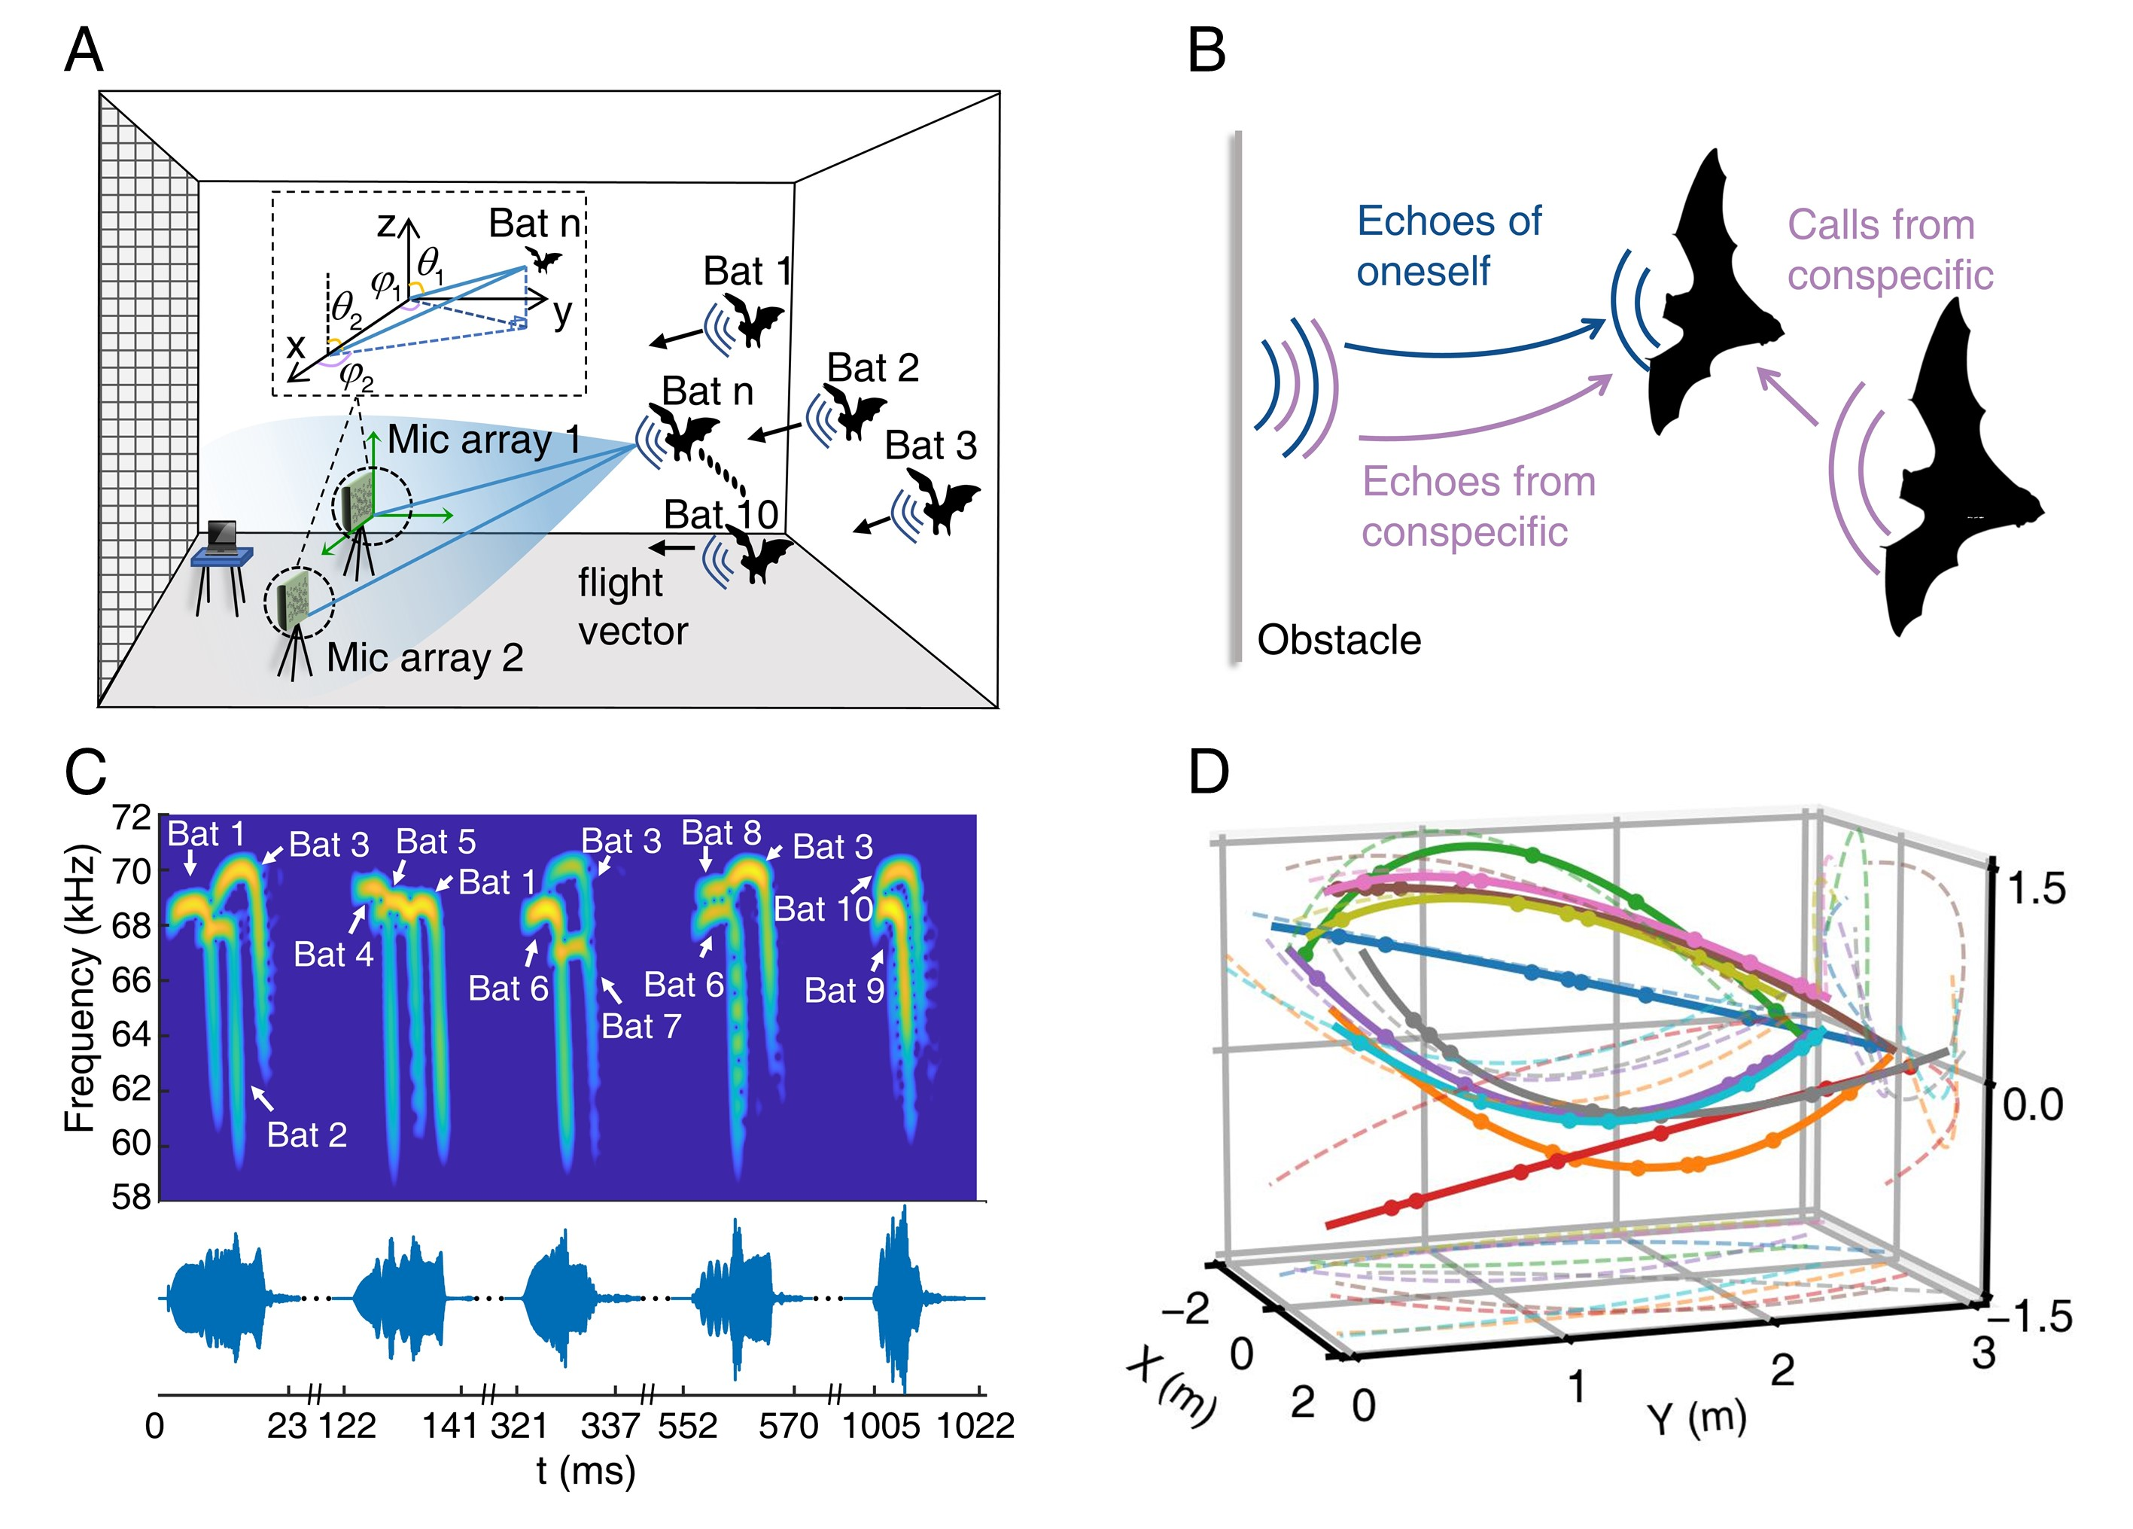

**Fig. 1.** **Group flight of *Hipposideros Armiger*.** **(A)** Graphic representation of experimental design. Bat call matching and 3D flight trajectories were determined by acoustically localizing bat calls using two microphone arrays. The bats were released simultaneously in front of the arrays. The three walls are devoid of any structures for the bats to perch on. The only presence of a hanging net behind the microphone arrays encourages the bats to fly toward these arrays. The bat flight vector indicates the direction of flight. For each array, we estimated the azimuth ( for array 1 and  for array 2) and elevation ( for array 1 and  for array 2) angles of bats as they emitted each echolocation call and calculated three-dimensional positional coordinates from the two arrays. **(B)** Illustration of potential interference elements in echolocation. The 'Echoes of oneself' refers to the echoes received by the focal bat, which is the signal emitted by the bat and reflected from the target and other individuals. 'Calls from conspecific' denote the direct signals the focal bat receives from other bats, which are not reflected off any other objects. 'Echoes from conspecific' are echoes received by the focal bat, which are signals from other bats after being reflected off the obstacle. Additionally, other bats also act as physical obstacles in the environment. **(C)** The spectrogram (top) and temporal waveforms (bottom) of the sounds emitted by individual bats were recorded with the microphone array. Signals from different bats were separated using LCMV spatial filtering and then matched with individual bats. **(D)** Three-dimensional trajectories of a particular group of 10 bats. The dotted lines are the projections of the trajectories on the 2D planes. Different colors correspond to different bats.

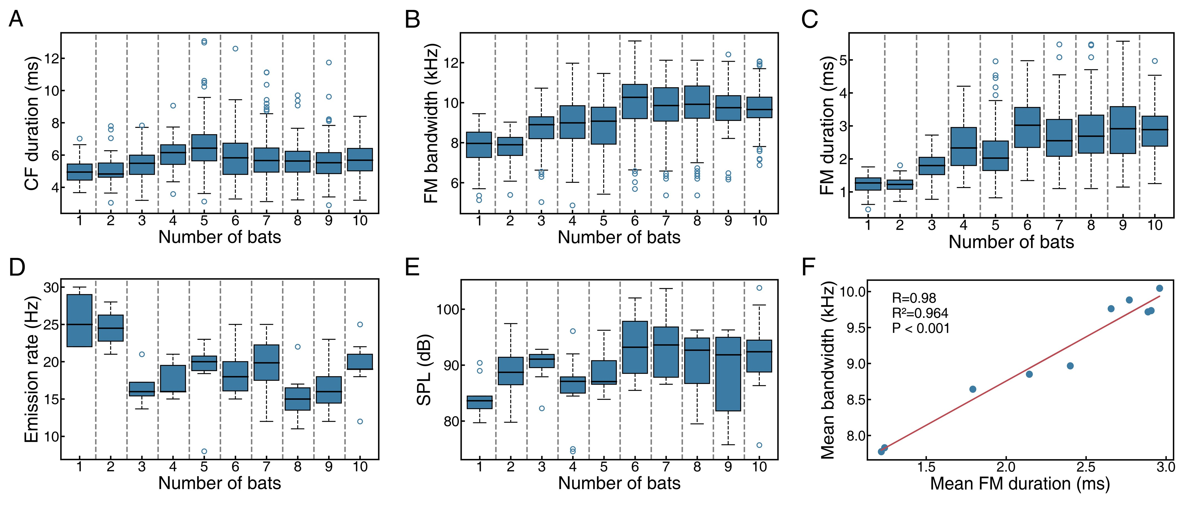

**Fig. 2. Acoustics changes of *Hipposideros armiger* in group flight experiment*.***Box plots of (**A**) CF duration, (**B**) FM bandwidth, (**C**) FM duration (**D**) emission rate and (**E**) SPL during flight for bat groups of varying sizes. (**F**) Scatter plots show correlation between the mean duration and mean bandwidth of the FM component under each flight condition. Solid line depicts linear regression. For the acoustics parameters (**A**, **B**, **C, D** and **E**), n=56, one; n=49, two; n=111, three; n=127, four; n=177, five; n=122, six; n=152, seven; n=235, eight; n=77, nine; n=192, ten.

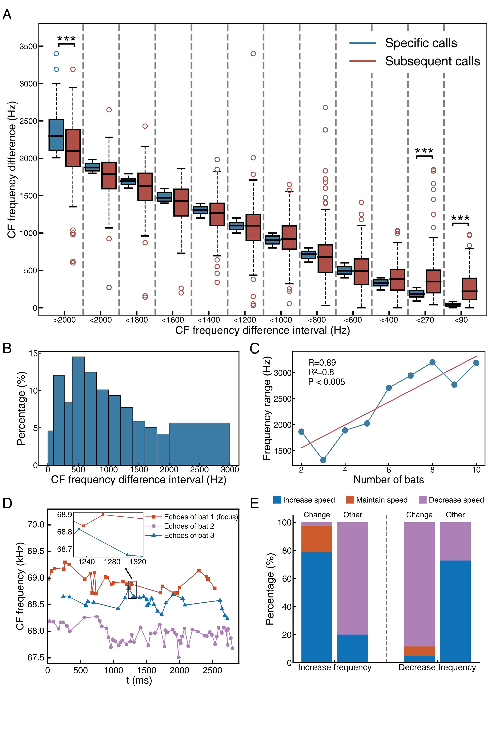

Fig. 3. Analysis of CF frequency differences with a focus on the relationship between flight speed adjustments and changes in emitted CF frequency. (A) Box plots illustrate the CF frequency differences between two bats at a specific moment (blue box), categorized into intervals: >2000 Hz, 1800-2000 Hz, 1600-1800 Hz, 1400-1600 Hz, 1200-1400 Hz, 1000-1200 Hz,800-1000 Hz, 600-800 Hz, 400-600 Hz, 270-400 Hz, 90-270 Hz, and 0-90 Hz, and comparing these with the CF frequency differences at the subsequent moment (red box). The estimated error in CF frequency difference follows a normal distribution with a mean of 0.31 Hz and a standard deviation of 45 Hz. Under a 95% confidence interval, the error range is determined to be ±90 Hz. (B) Distribution of interval differences out of the total observed differences. (C) Frequency ranges occupied by the CF frequencies during flight for bat groups of varying sizes. Blue line shows correlation between the number of bats and the CF frequency range occupied by the bats under each flight condition. Red solid line depicts linear regression. (D) Within the black box, signals with a CF difference of 19 Hz were both generated before the subsequent calls of another bat, with an increase in the CF frequency difference of subsequent calls. (E) The relationship between the adjustments in flight speed and the changes in emitted CF frequency. \**P <* 0.05, \*\**P <* 0.01, \*\*\**P <* 0.001 for Wilcoxon Signed-Rank test in (A).